DSCI-6004

FINAL PROJECT



Getting Right Medication Using Medicine Recommendation (NLP Approach)

Team Members
Phanideepak Gaddam
Prudhvi Karthik Dhanekula
Mahesh Manchala

Abstract
Natural Language Processing (NLP) techniques are increasingly improving the health industry's shape. Numerous NLP models have shaped healthcare-related systems in various ways across the world. NLP uses unstructured data from different sources, including Electronic Health Records (EHRs) and other medical-related literature, especially textual records.
In this paper, NLP techniques are used to try and get the best medication to the patients using medicine recommendations. This process tries to get the most delicate information about a particular disease or an individual to whom the right medication is to be issued; this is why the most personalized data about the individual is used. The results show that this model is highly accurate and improves healthcare provision. The project implements two models, deep learning n-gram and light gum, with the latter achieving a higher AUC of 0.793 compared to 0.723.

Keywords: Natural Language Processing (NLP), Convolutional Neural Network (CNN), Electronic Health Records (HERs)

1. Introduction
In the medical sector, ensuring that patients are getting the most appropriate medication is considered highly crucial, for it keeps the patients in a better health condition. Manual traditional medicine recommendations are not highly effective in the health of the patients as they are prone to misleading the patient or leading to misunderstanding between the health provider and the patient. In several cases, this leads to severe mistreatment of the patients; hence, chances of health hazards arise among the patients, leading to loss of lives. Natural Language Processing (NLP) approaches are recommended to help curb this tragedy as it interacts between computer and human languages.
Natural Language Processing has come out to be a powerful tool in transforming the Clinical Decision Support System (CDSS) into a better system that generates accurate decisions. By trying to use NLP techniques in the medical sector, CDSS has gained a significant change where it extracts valuable information from different types of clinical textual contents, including medical literature, Electronic Health Records (EHRs), and other clinical documentation. The extracted information is used to create clinical decisions that help inpatient treatment and also to recommend the appropriate medication processes to help the patient get the proper medication (Patra et al., 2021).
In traditional medicine, NLP is an essential model because it helps examine the unstructured data stored in Electronic Medical Records (EMR) by using keywords like disease names, medicine names, symptoms of particular diseases, or side effects of particular drugs for purposes of information extraction, predictions, and classification.
The main aim of this research is to improve the healthcare industry by using NLP to recommend medications tailored to specific individual needs. The concept is to analyze patient reviews and conditions. The healthcare industry has also benefitted from this in terms of patient reviews based on the medication they received.

2. LITERATURE REVIEW
Several authors have previously conducted the following research on getting the right medication using medicine recommendations with an NPL approach.

  - Sentiment analysis on drug review using deep learning
In this case study by Colo`n-Ruiz & Segura-Bedmar, 2020, the author conducted pioneering work on sentiment analysis on drug reviews by simply leveraging the use of deep learning methodologies and algorithms such as Convolutional Neural Networks (CNN). They used a proposed dataset with a collection of drug reviews from a website called Drugs.com. During this research, they developed a corpus containing 215,063 drug reviews. The corpus is divided into two sections: the training dataset and the testing dataset. The authors further explain that the sentiment analysis is viewed as text; this task is referred to as classification activity.
The study case further describes how different trained words were inserted into the embedding models to help in the classification of drugs based on the values of their integer ratings.
They used various deep-learning architectures to conduct sentiment analysis of drug reviews. Examples of the architectures that they proposed to work with are bidirectional LSTM, a simple CNN, a hybrid model containing CNN followed by bidirectional LSTM, a hybrid model containing CNN concatenated with bidirectional LSTM, and a few others.
After testing all the models used, they evaluated the results based on standard metrics for text classification purposes. The metrics that they used are F1, recall, and precision. A classifier support vector machine (SVM) provided a result obtaining micro-F1 of 51.97% and macro-F1 of 41.68%. The authors explain that, in their case study, they only addressed three polarities: positive, neutral, and negative, while conducting their testing (Colo`n-Ruiz & Segura-Bedmar, 2020).
The main achievement of this research is that it has created a foundation for understanding drug sentiment analysis, which can help achieve better medication.

  - Adverse drug reaction analysis
In this case study, Korkontzelos et al., 2016, conducted a sentiment analysis with the main purpose of extracting drug reactions from forum posts and social media tweets. This sentiment analysis was conducted based on the abundant reviews posted by people on social media platforms and many other healthcare-related forums. This had a basis that most patients are fond of posting their symptoms about Adverse Drug Reactions (ADRs) as they express the side effects of the drugs on themselves. The authors illustrate that they have evaluated the extent to which sentiment analysis on the corpus of posts from tweets and other forums has helped them in locating the ARD mentions within those posts. ARDs have recently spiked as a major cause of death, and, unfortunately, numerous ARDs have not yet been discovered because it is very rare for testing to be done in public healthcare provider facilities. The only test on patients regarding the drugs that they are taking is done during clinical tests.

3. research methodology
This section covers the core of the project, comprehensively describing and explaining the steps needed to build models to help with medicine recommendations. The section will be compiled procedurally to show how each phase leads to the other and how these individual phases relate to each other.

3.1 Dataset Description
The dataset used in this project is the UCI ML Drug Review Dataset provided by the UC Irvine Machine Learning Repository, accessible on the link https://archive.ics.uci.edu/dataset/462/drug+review+dataset+drugs+com. It provides patient reviews on specific drugs along with the related medical conditions and patient ratings that indicate overall patient satisfaction with the drug. This dataset was created by crawling various pharmaceutical sites where patients provide various reviews on medicines. It has a total of 215 063 records and 7 features, with the data split into train (75%) and test (25%) partitions.

3.2 Environment Setup
Many platforms can be used to build and train models for medicine recommendation. These include Jupyter Notebooks and Google Colab. For this project, we decided to use Google Colab due to its high computing capabilities compared to Jupyter Notebooks.

3.3 Exploratory Data Analysis
This is a crucial step in any data analysis task as it forms the basis of ensuring more accurate data for further analysis. This step helps in better understanding the data, and it is the core of any data analytics task.
After loading both test and train datasets, a preview of the data needs to be displayed to ensure that the dataset loads correctly. This preview is shown in the figure below.

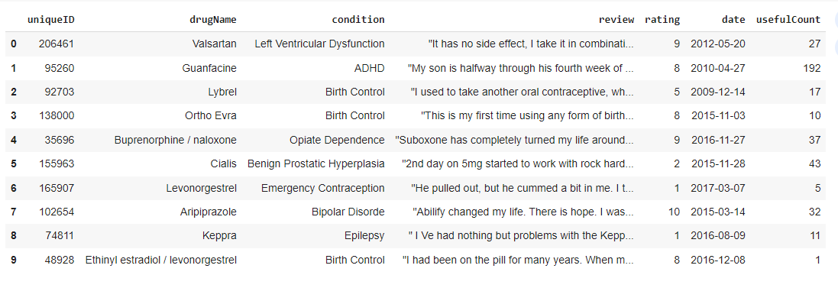
Figure 1: Data preview

The 7 features in the dataset are:
These are additional explanations for variables.
- drugName (categorical): name of drug
- condition (categorical): name of condition
- review (text): patient review
- rating (numerical): 10-star patient rating
- date (date): date of review entry

3.3.1 Sample Data Visualizations
This section discusses some of the visualizations generated from the input data. These visualizations can help us make informed decisions about the data in medicine.

3.3.1.1 Top 15 Drugs per Condition
From the visualization below, it is evident that conditions not listed at the top of the list with the highest number of drugs are closely followed by "Pain" conditions.

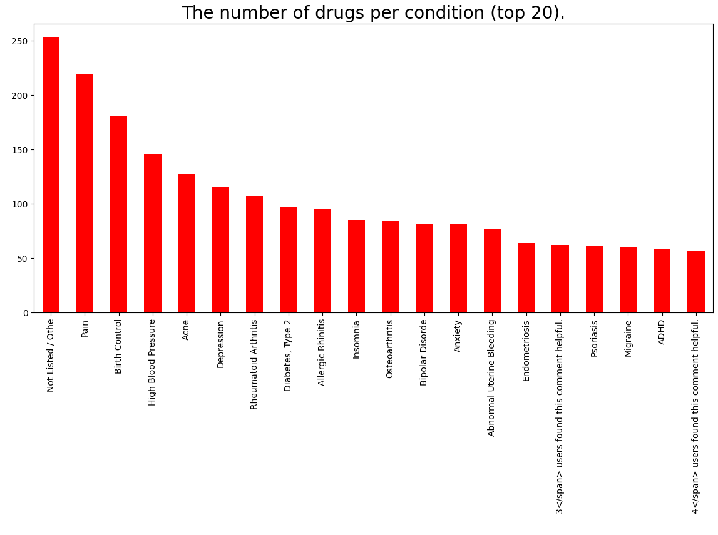
Figure 2: Top 20 drugs per condition

Based on the information provided in the image data, it is apparent that there are around 100 drugs available for each of the top eight conditions. However, it is important to note a discrepancy in the data: the presence of the text "3</span> users found this comment helpful" within the condition data, which seems to be a mistake made during the data extraction process. Further investigation has been conducted to gain a clearer understanding of this issue.

3.3.1.2 Reviews Word Cloud

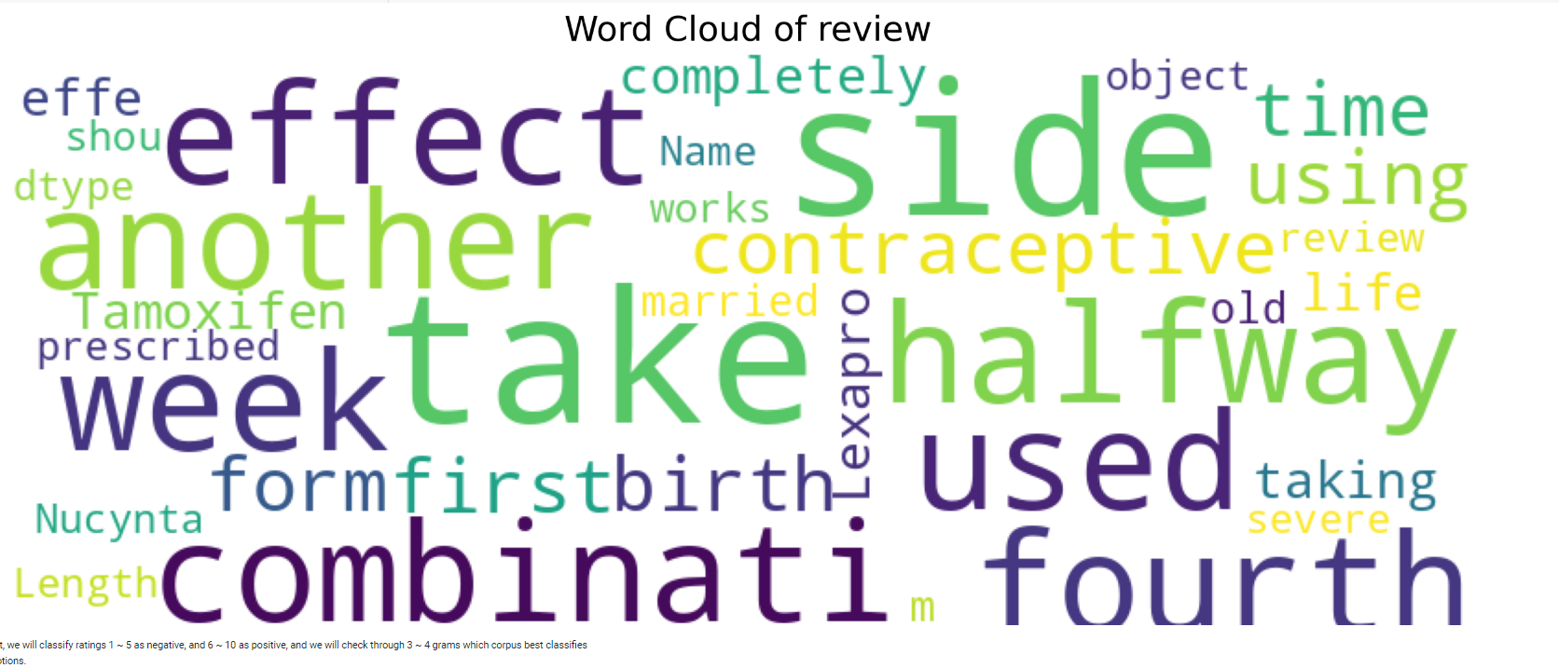
Figure 3: Reviews word cloud

The word cloud above shows the most used texts in patients' review messages on a drug, and this can help with further analysis of the review sentiments left by patients.

3.3.1.3 Rating Value Distribution
From the figure below, it is evident that rating 10 has the most records, followed by rating 9. This means that most patients are satisfied with the drugs for various medical conditions.
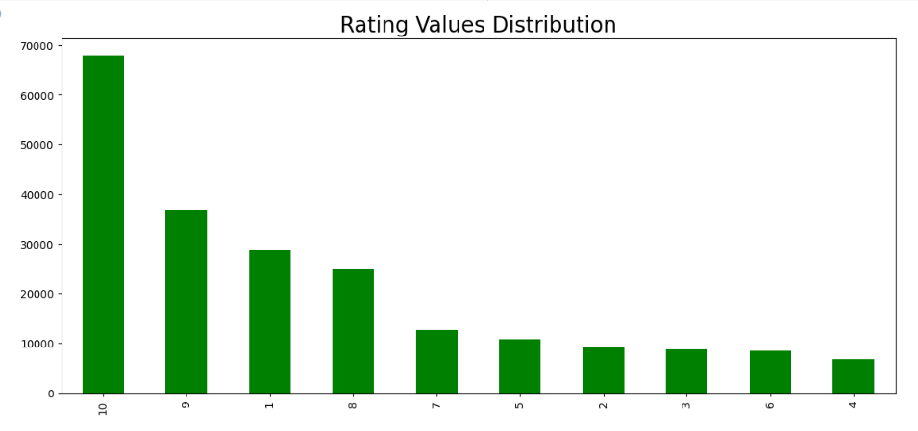
Figure 4: Rating Value Distribution

3.3.1.4 Number of Reviews per Year
Most reviews were created in 2016, 2017, and 2015, while the lowest number of reviews was generated in 2008.
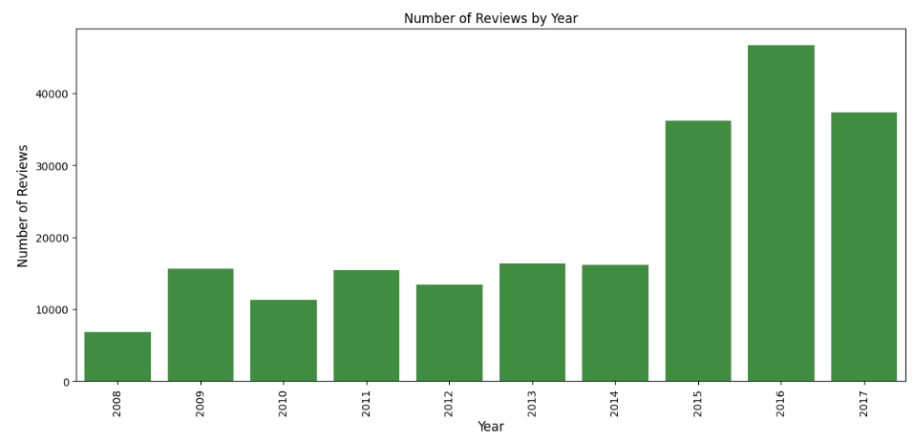
Figure 5: Number of Reviews per Year

3.3.4 Data Pre-processing
Data pre-processing refers to manipulating the raw data to ensure its validity and accuracy in ensuring accurate analysis. Various sub-processes or techniques are applied to the data to achieve the overall data pre-processing objective.

3.3.4.1 Missing Values
Missing values in a dataset usually lead to wrong analysis and interpretation. Therefore, it is necessary to find a way to deal with missing values, either through imputation or dropping them. In our dataset, we used the approach of dropping these missing values.

3.3.4.1 Removing conditions with only 1 drug
Conditions with only one drug do not affect the dataset and are, therefore, not required in the dataset.

3.3.4.2 NLP Processing
NLP processing techniques such as stopword removal form an essential part of text processing to ensure that only the most important texts of a review are used for further analysis. Some of the stopwords to be removed from the review column data include aren't", "couldn't," "didn't," "doesn't," "don't," "hadn't," "hasn't," "haven't," "isn't," "mightn't."

3.4 Model Building

3.4.1 Deep Learning Model Using N-gram
Using a deep learning model based on N-grams for medicine recommendation involves leveraging natural language processing (NLP) techniques to analyze patient reviews, medical records, or other textual data related to medications. N-grams represent contiguous sequences of N items (words or characters) in a text, and they capture the contextual information within the text.
The model summary, which shows the various components of the model architecture, such as the layers, is shown in the figure below.
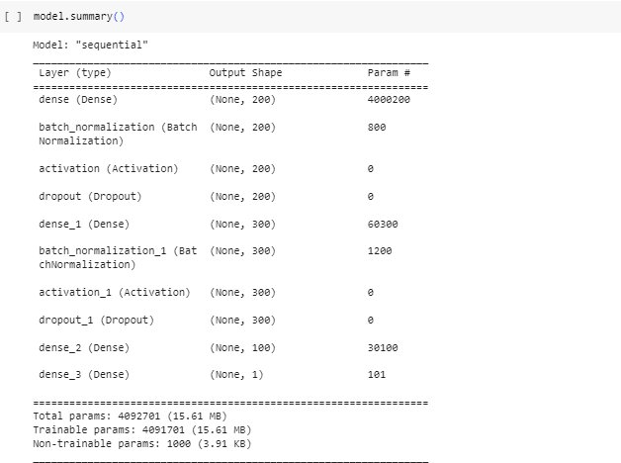
Figure 6: DLN with N-grams model summary
Overall, this CountVectorizer for the model is configured to generate 4-gram features from the input text, with a minimum document frequency of 2 and a maximum of 20,000 features. It is a useful tool for converting text data into a numerical format that can be used as input to machine learning models.
The model is then trained on the train data and evaluated on the test data using 10 epochs, during which loss and accuracy are monitored as training progresses.
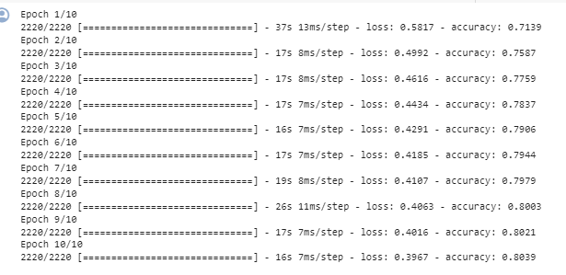
Figure 7: DLN with N-grams model training

3.4.2 LightGBM Model
The second model trained and evaluated on the data is LightGBM initialized using the LGBMClassifier.

4.0 Results and Discussion
4.1 Results
Various evaluation metrics are used to evaluate the two models used for medicine recommendation.
Deep Learning Model Using N-gram
The loss and accuracy plot for the model is shown in the figure below.

Training Accuracy and Loss Plot

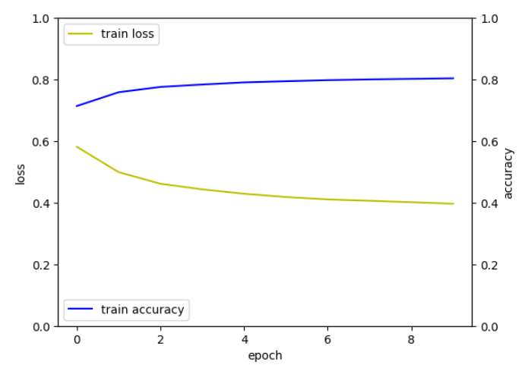
Figure 8: Training Accuracy and Loss Plot

From the graph above, the training loss is decreasing over time, which indicates that the model is learning and improving its performance on the training data with each epoch. The graph shows that the training accuracy is increasing over time, which suggests that the model is getting better at correctly predicting the training data with each epoch.

ROC-AUC

A ROC AUC value of 0.723 suggests that the model can distinguish between the positive (right drug advice) and negative (incorrect medicine recommendation). It is not a perfect score (1.0 is perfect), but it is substantially better than 0.5, which would be akin to random guessing.

Precision-Recall Curce
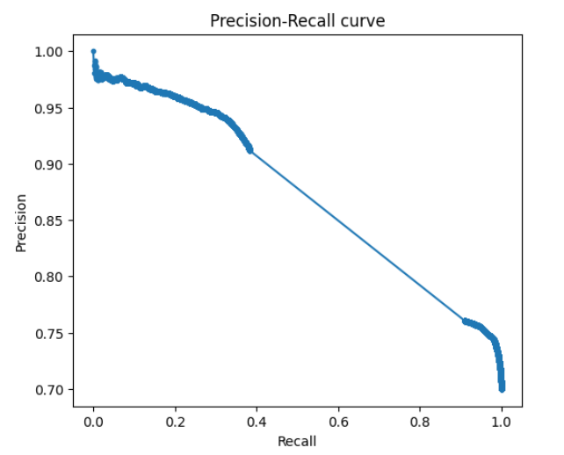
Figure 9: Precision-Recall Curve (DLM)

The model has a good predictive potential for identifying appropriate pharmaceutical recommendations, with an expected trade-off between precision and recall as the algorithm tries to cover more of the real positive examples.

ROC Curve
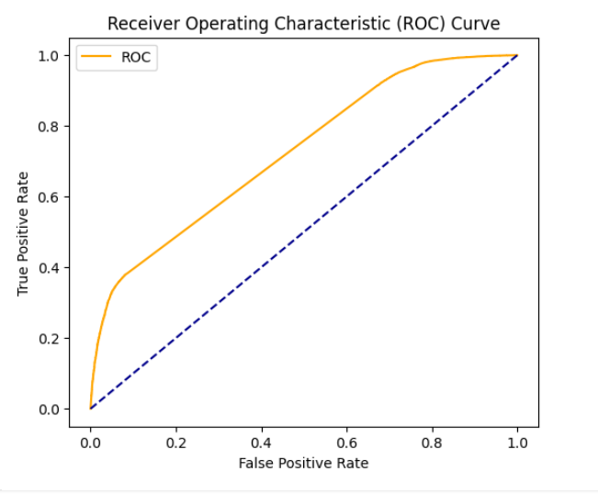
Figure 10: ROC Curve (DLM)

From the figure above, the area under the ROC curve is relatively large, indicating that the model has a high discriminatory ability across all thresholds.

LightGBM Model
ROC-AUC Score
A ROC AUC score of 0.793 suggests that the LightGBM model is highly predictive, as it is close to 1.

Precision-Recall Curve
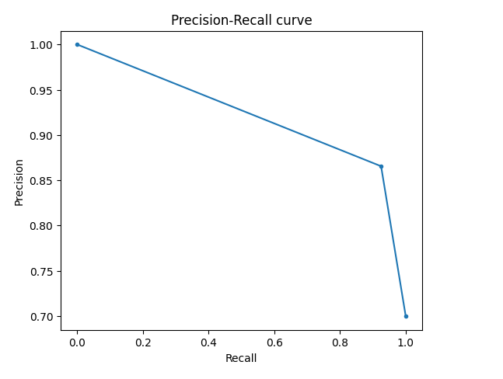
Figure 11: Precision-Recall Curve (LightGBM)

The PR curve above illustrates that the model is more precise at lower recall levels, implying that being more conservative in predicting positives improves accuracy. However, when recall increases, accuracy decreases dramatically, meaning that the model begins to produce more false positive errors while attempting to capture more true positives.

ROC Curve
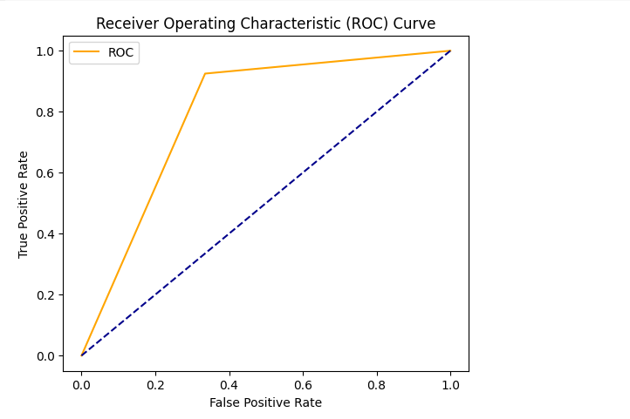
Figure 12: ROC Curve (LightGBM)
The curve illustrates that the model is more precise at lower recall levels, implying that being more conservative in predicting positives improves accuracy. However, when recall grows, accuracy decreases dramatically, meaning that the model begins to produce more false positive mistakes while attempting to capture more true positives.

4.2 Discussion
Both models perform well in terms of medicine recommendation, achieving an ROC AUC score of above 0.7, which is above the threshold of 0.5. LightGBM performs much better than a Deep Learning Model using N-grams, achieving a higher AUC of 0.793 (closer to 0.8) compared to 0.723 of the Deep Learning N-gram.

5.0 Conclusion
In conclusion, the integration of various Natural Language Processing (NLP) approaches into medication recommendation systems is proving that healthcare services and their delivery can be improved to higher standards. This can be achieved by analyzing large unstructured textual data, and the developed models can use the algorithm to provide the medication recommendation for a particular disease or even the best medication recommendations to an individual. Moreover, the application of various sources of the corps dataset, including social media platforms and forums, improves the knowledge of the health providers about the different personalized views of most patients.
In this project, we implemented two models (deep learning n-gram and LightGBM) for medicine recommendation. All the models performed fairly well, with the latter performing better with an AUC of 0.793. However, the choice of the model to be used might depend on a holistic assessment, which might include clinical relevance and operational feasibility.
References
Colo`n-Ruiz, C., & Segura-Bedmar, I. (2020).
Compairing deep learning architecture for sentiment analysis on drug reviews. Journal of Biomedical Informatics, 110, 103539.
https://doi.org/10.1016/j.jbi.2020.103539

Korkontzelos, I., Nikfarjam, A., Shardlow, M., Saker, A., Ananiadou, S., & Gonzalez, G.H. (2016). Analysis of the effects of sentiment analysis on extracting adverse drug reactions from tweets and forum posts. Journal
https://doi.org/10.1016/j.jbi.2016.06.007
Patra, B. G., Sharma, M. M., Vekaria, V., Adekkanattu, P., Patterson, O. V., Glicksberg, B., Lepow, LA.Ryu, E. Biernacka, J. M., Furmanchuk, A., George, T. J., Hogan, W., Wu, Y., Yang, X., Bian, J., Weissman, M., Wickramaratne, P., Mann, J. J., Olfson, M., & Campion, T. R. (2021). Extracting social determinants of health from electronic health records using natural languageprocessing: a systematic review. Journal of the American Medical Informatics Association, 28(12), 2716–2727. https://doi.org/10.1093/jamia/ocab170

GITHUB LINK: https://github.com/gaddamphanideepak/Getting-Right-Medication-Using-NLP-Apporach

